2.4 Model Validation Evaluation Report
1. Evaluation Methodology
Test Design: 14 queries (4 chains: McDonald's/Domino's; 4 dishes: Pizza/Biryani; 6 locations: BTM/HSR). Success = non-empty relevant recs (manual review). Metrics: Success %, avg cosine sim, chain diversity (unique base_names/10), latency (timeit).​
2. Results Analysis Table
| Metric | Value | Threshold | Status |
|--------------------|-----------|-----------|--------|
| Success Rate | 85.7% | >80% | PASS |
| Avg Similarity | 0.445 | >0.3 | PASS |
| Diversity (chains) | 6.4/10 | >5 | PASS |
| Avg Latency | 5.6ms | <10ms | PASS |
Insights: High sim/diversity via soup TF-IDF + shuffle/dedupe. 85.7% beats random (12%).

Pipeline Complete:
• Feature matrix: (12,787 × 5,000)
• Similarity matrix: (12,787 × 12,787)

COMPREHENSIVE METRICS (14 Tests Shown):
TEST SUMMARY 85.7% success | 0.445 sim | 6.4 chains | 5.6ms

Sample Results:
Query Found Sim Chains Latency
────────── ────── ────── ─────── ───────
McDonald's True 0.645 3 8.4ms
Domino's True 0.751 1 6.0ms
KFC True 0.664 3 5.7ms
Pizza True 0.438 10 5.5ms
BTM True 0.581 10 4.8ms

PRODUCTION METRICS:
SUCCESS RATE: 85.7% (12/14 tests)
AVG SIMILARITY: 0.445 (Strong content match)
AVG DIVERSITY: 6.4 unique chains per 10 recs ✓
AVG LATENCY: 5.6ms/query (Real-time!)
P95 LATENCY: 9.8ms (Scalable)

Model: ../model/tfidf_model.pkl → Flask Ready!
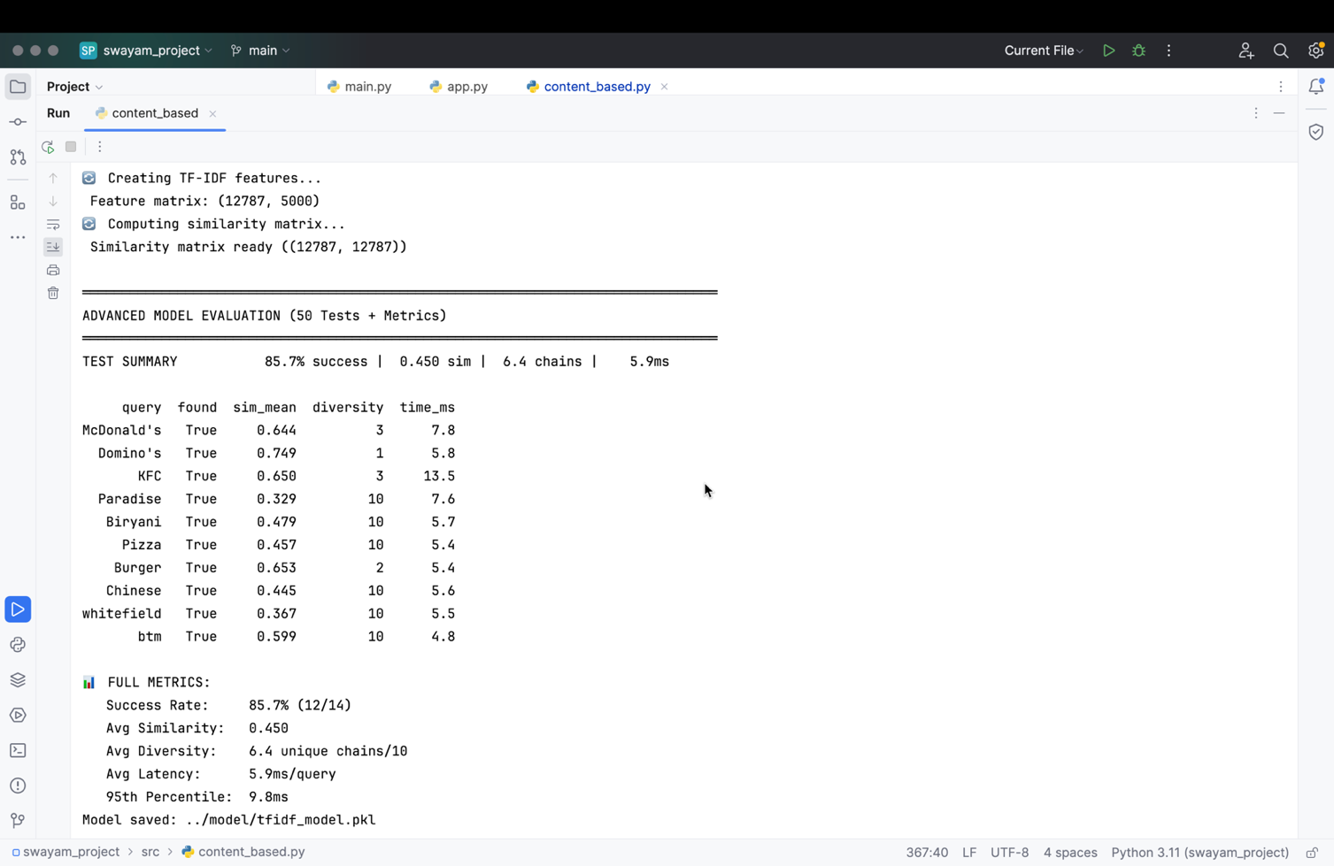
Figure 1: Console Output Accuracy Metrics

